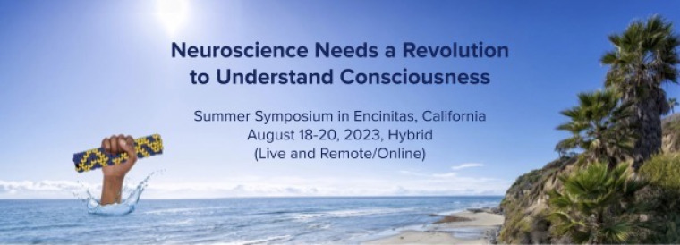
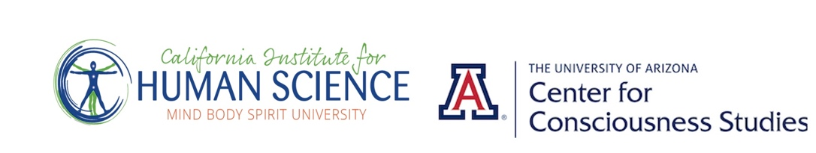

Revised PROGRAM August 14

Neuroscience Needs a Revolution to Understand Consciousness
Summer Symposium at CIHS Campus, 701 Garden View Court
August 18-20, 2023 – Encinitas, CA
Sponsored by California Institute for Human Science
Center for Consciousness Studies

Friday August 18, 2023

1:00 pm Welcome/Opening Session
Thomas Brophy, President CIHS
Stuart Hameroff Director CCS
1:05-1:15 Award presentation to Mani Bhaumik

1:15 p.m. Plenary Program
Paradigm Shifts
1:15-1:45 Paavo Pylkkanen
1:45-2:00 Riccardo Manzotti
2:00-2:15 Tom Bever

Entanglement and Photons in the Brain - Christof Simon, Anirban Bandyopadhyay
2:15-2:45 Christof Simon
2:45-3:15 Anirban Bandyopadhyay

3:15–3:45 break

Quantum Optics of Microtubules
3:45-4:15 Aarat Kalra
4:14-4:45 Travis Craddock
Paradigms and Phenomenology of the Revolution
4:45-5:05 Hide Saegusa
5:05-5:25 Thomas Brophy
5:25-5:45 Sean Esbjörn-Hargens

Friday evening, CIHS Fountain area
5:45-6:30 p.m. - Drinks, Food, Informal Talk

‘Spiritual and Therapeutic Aspects of Ayahuasca’
6:30-7:15 Paulo Roberto Silva de Souza, Padrinho, Church of Santo Daime,
Rio de Janeiro, Brazil

Saturday August 19, 2023

9:00 a.m. Plenary Program

Microtubule Biology
9:00-9:30 Kassandra and Rick McKenney
9:30-10:00 Rajnish Khanna

Free Will and Retroactivity
10:00-10:30 Sir Roger Penrose
10:30-11:00 Daniel Sheehan

11:00-11:30 break

Astrobiology and Astro Consciousness
11:30-12:00 Dante Lauretta
12:00-12:30 Stuart Hameroff

12:30-2:00 lunch

2:00 p.m. Plenary Program

Spintronics in Neuroscience
2:00-2:30 Luca Turin
2:30-3:00 Marilu Chiofalo

Measuring Consciousness Proximity
3:00-3:30 Santosh Helekar
3:30-4:00 Dean Radin

4:00-4:15 break

Keynote:
Quantum Consciousness
4:15-5:15 Hartmut Neven
5:15-6:30 Saturday evening reception - TBA
Drinks Food, Informal Talk

Sunday August 20, 2023

8:30 a.m. Plenary Program

Varieties of Conscious Experience
8:30-8:50 Jeffery Martin
8:50-9:10 Deepak Chopra
9:10-9:30 Aliya Grig

Physics of Microtubules
9:30-10:00 Jack Tuszynski
10:00-10:30 Esh Farschi

10:30-11:00 break

EM Fields
11:00-11:30 Tam Hunt
11:30-12:00 Dimitris Pinotsis
12:00-12:30 Anirban Bandyopadhyay

12:30-2:00 lunch

2:00 p.m. Plenary Program

Therapeutic NeuroUltrasound
2:00-2:30 Jay Sanguinettti
2:30-3:00 Sterling Cooley

Sensors and Machines
3:00-3:30 Zina Cinker and Caroline Aguilar
3:30-4:00 Anita Goel

4:00-4:30 break

Comparing Theories of Consciousness
4:30-5:00 Kelvin McQueen
5:00-5:30 Nicolas Rosseinsky
5:30-6:00 Paul Nunez

Future Research and Technology
Round Table Discussion

Conference Close

Sponsors
Mani Bhaumik
Google Quantum AI
Eugene Jhong
Center for Consciousness Studies
California Institute for Human Science
Journal of Consciousness Studies

Exhibitors
Interchange Laboratories Inc. " Mind-Interface Technology"
Valis, Inc.
Cosmointel Research
USD MePMoS Lab
Sema Lab

Special thanks
Encinitas Chamber of Commerce
Minuteman Press Encinitas
Encinitas Ballet Academy
Boochcraft Hard Kombucha
G's Ginger Beer

Audio Visual
Daniel Barre, Realist Films

Venue
California Institute for Human Science
701 Garden View Court, Encinitas, CA 92024

Days/Times: Pacific
August 18, 2023 - 1:00 pm-6:30 pm
August 19, 2023 - 9:00 am-7:15 pm
August 20, 2023 - 8:30 am-6:00 pm

Registration
Eventbrite

Symposium
Format: Hybrid – Live - Remote/online
Invited Plenary Speakers, plus accepted digital showcase talks,
poster presentations, exhibitors.
Digital Files will be uploaded for on-demand viewing.
Exhibitors, Poster presenters will be active during break time and
social breaks.

Promo: Please share the Promo video link with your social groups.
https://vimeo.com/845485065

Media Files
Social Media
Twitter Message

Contacts:
Stuart Hameroff: stu.hameroff@gmail.com
Thomas Brophy: thomas_brophy@cihs.edu
Abi Montefiore: center@arizona.edu

